251805044 Görkem Bozkaya Computer Networks Web Server Assignment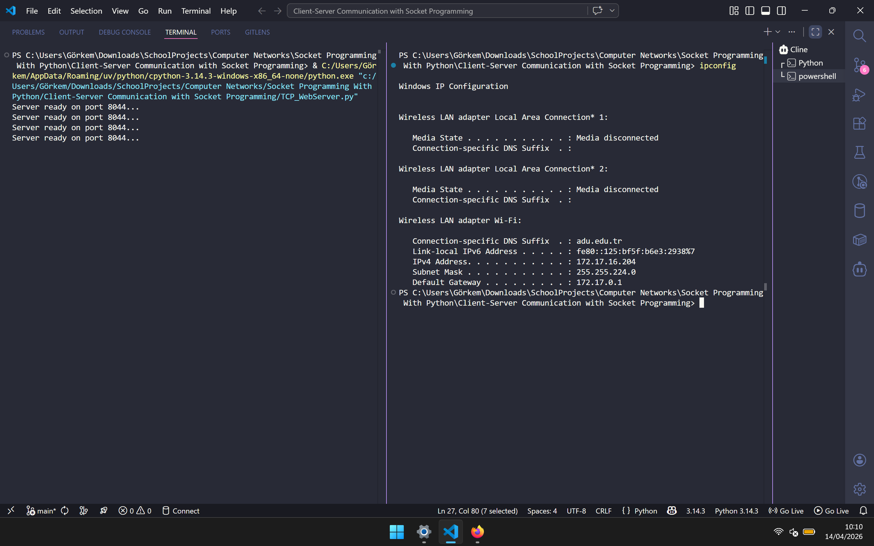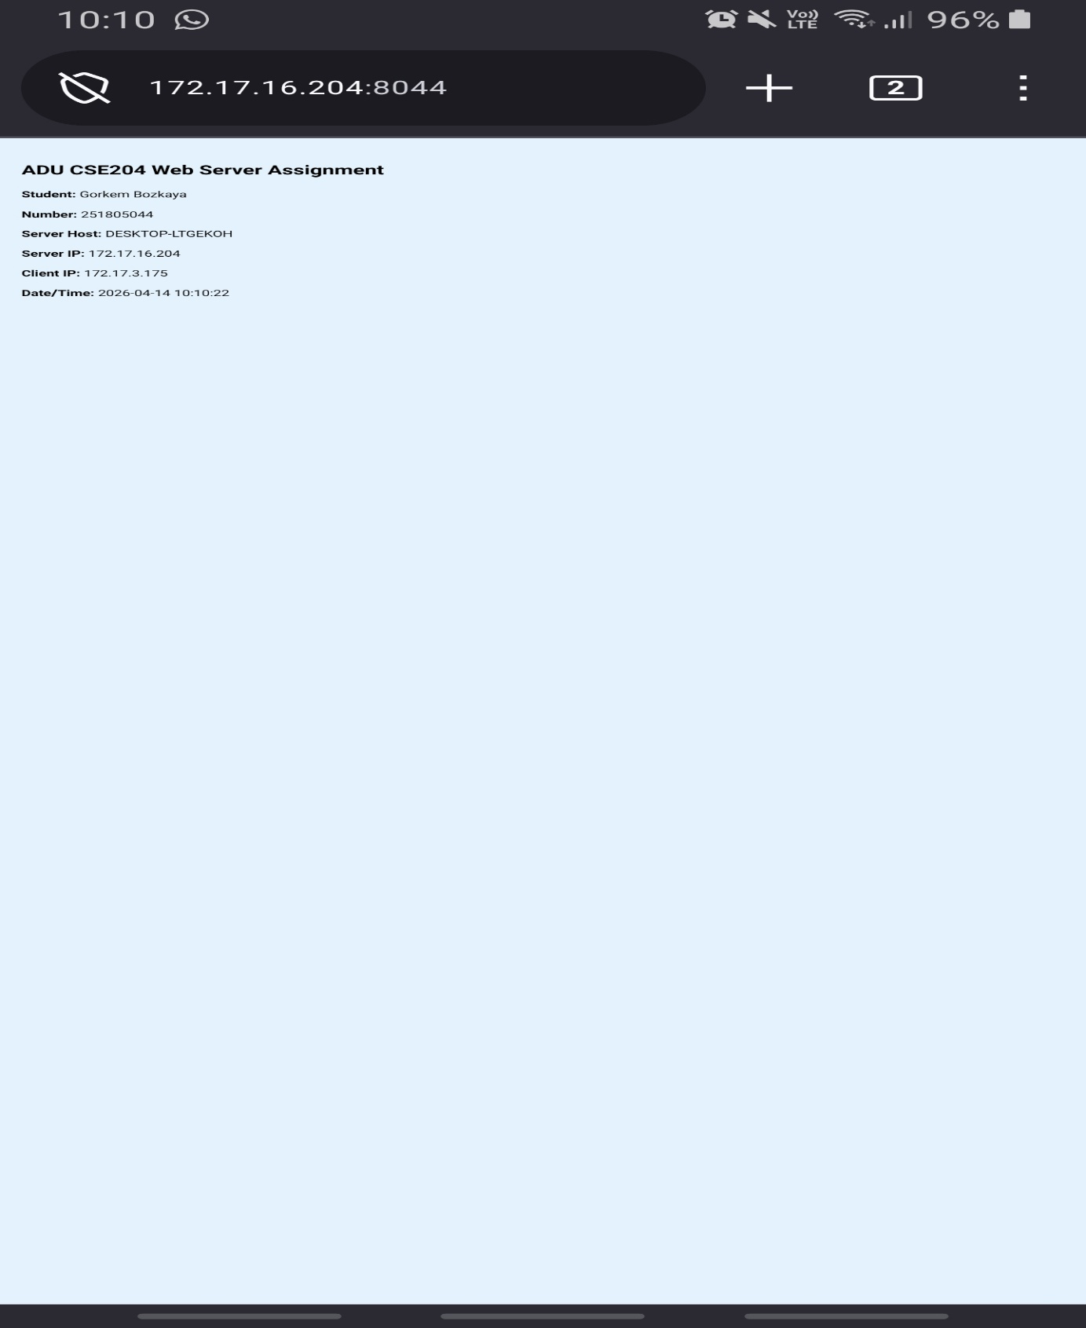
These screenshots demonstrate the successful execution of the TCP Web Server assignment across two different devices. The terminal view shows the Python server actively running and bound to the host IP 172.17.16.204 on port 8044. The mobile browser view confirms a successful client connection from a distinct IP address (172.17.3.175) over the local network. The server correctly responded with the dynamically generated HTML page, accurately displaying the student credentials, network parameters, timestamps, and the assigned background color. This completely fulfills the 100-point requirement for multi-device server-client communication.

